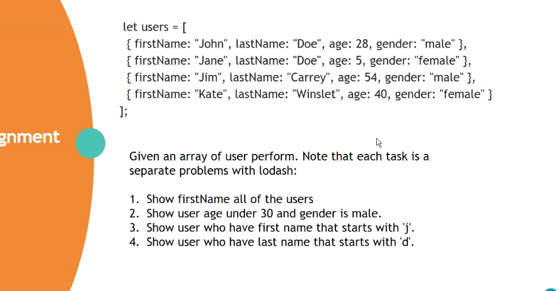

Create calculator to multiplication number Create calculator to Substaction number Create calculator to division number Create calculator to exponentation number Create calculator to modulus number With 2 Parameters